C950 Task-2 WGUPS Write-Up

(Task-2: The implementation phase of the WGUPS Routing Program).

Jordan-Elijah Baez
ID # 011163565
WGU Email: jbaez65@wgu.edu
2/12/2025

C950 Data Structures and Algorithms II

A. Hash Table
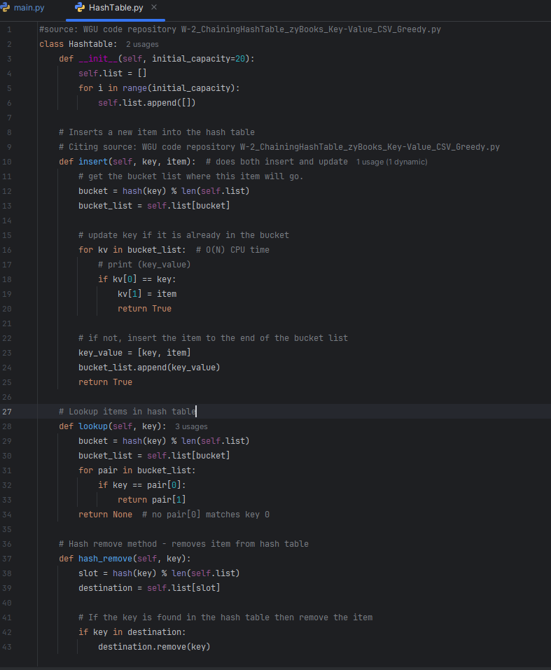

B. Look-Up Functions
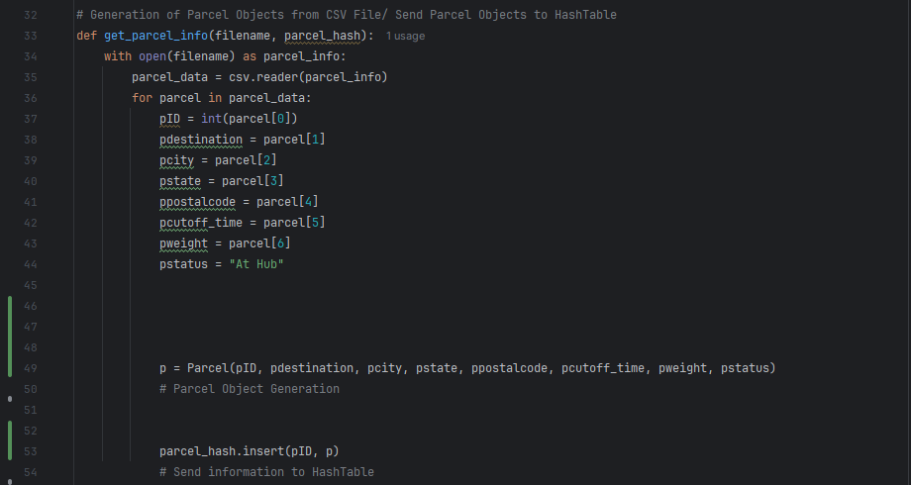

C. Original Code
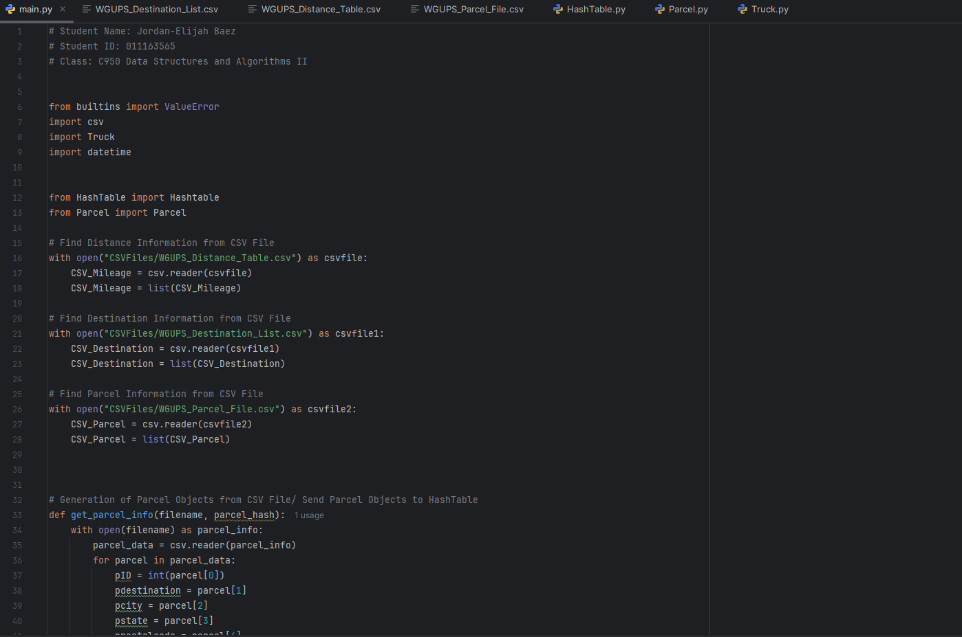
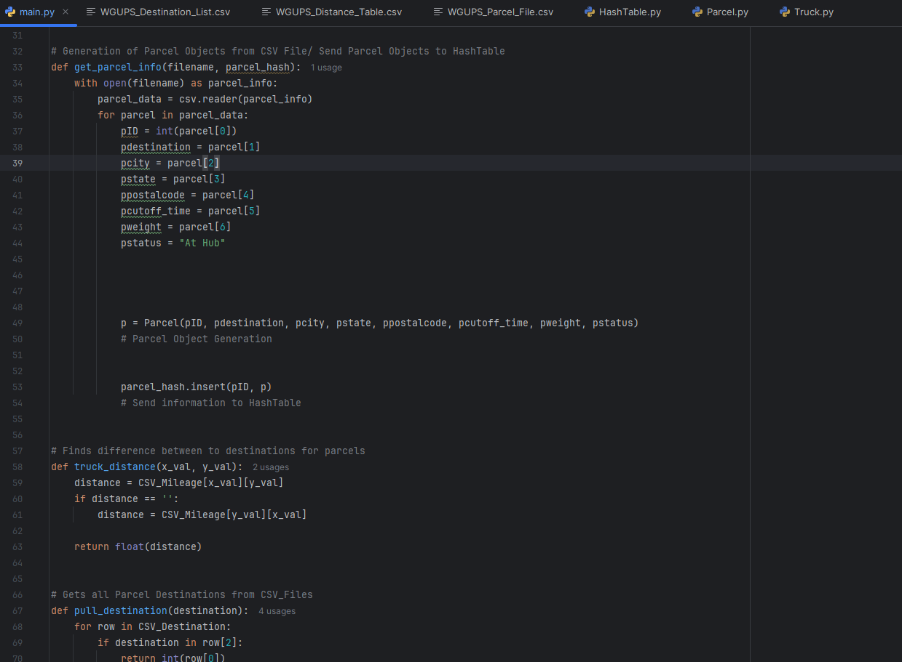

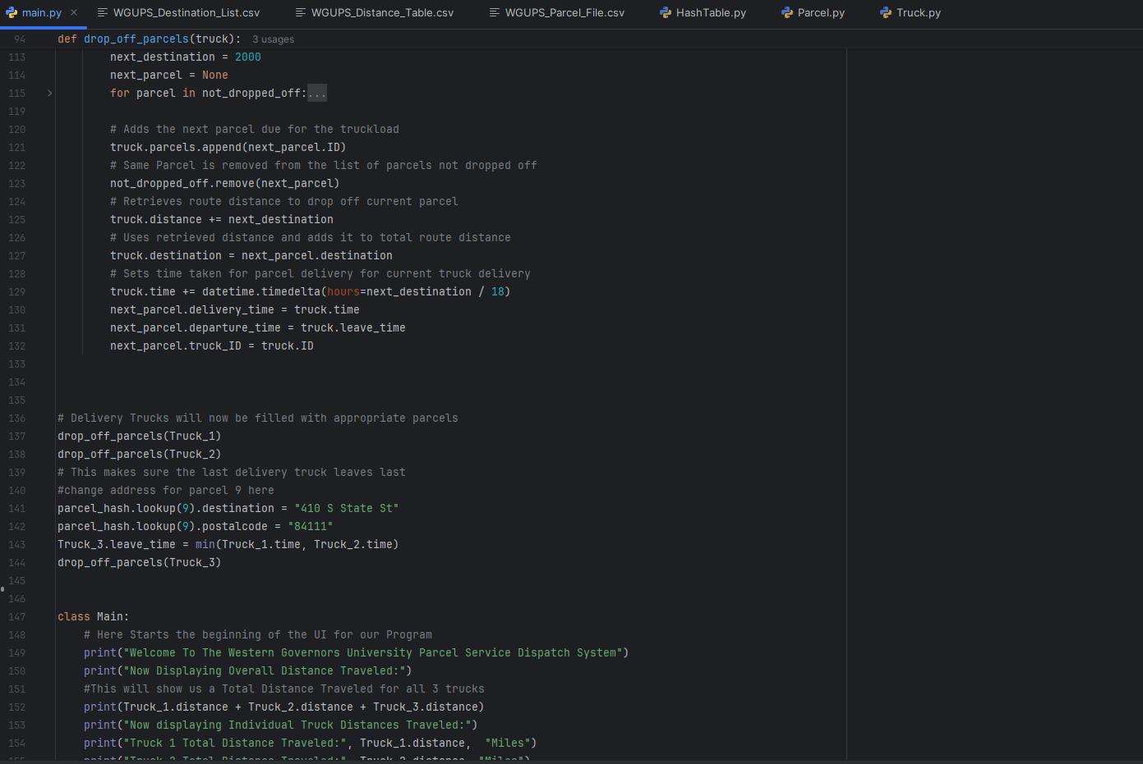
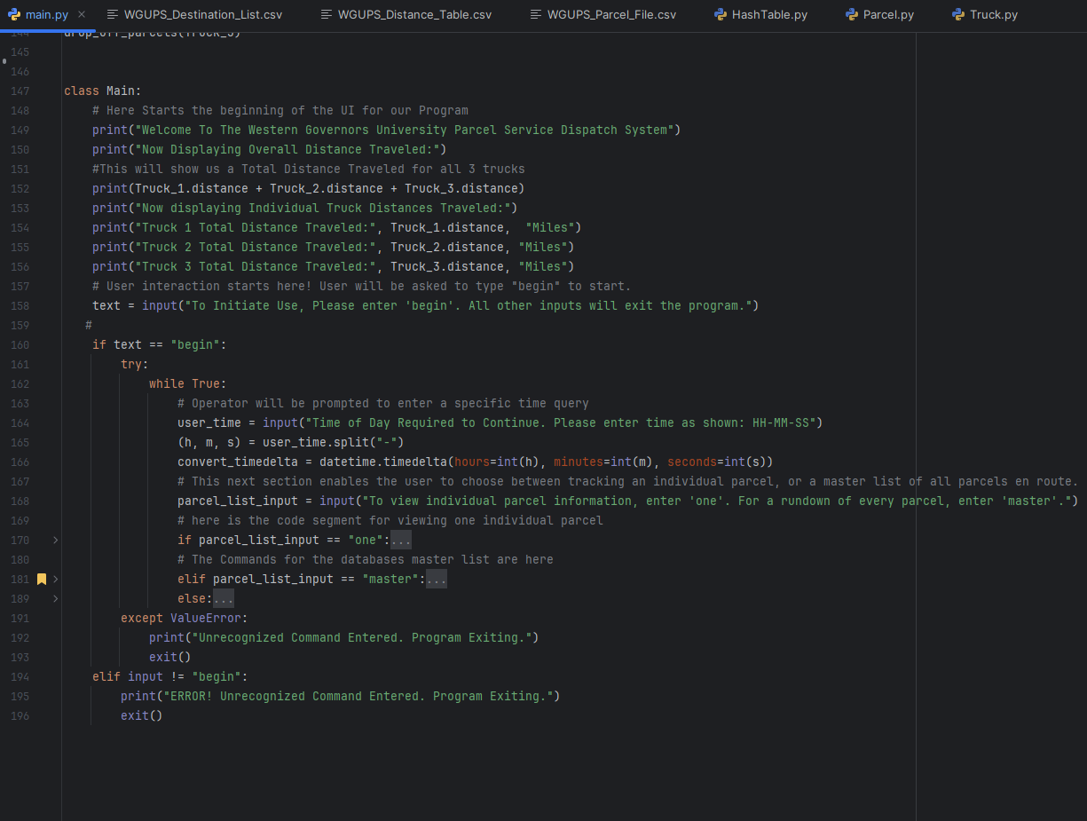

C1. Identification Information
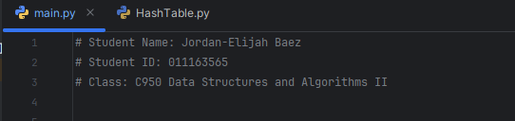

C2. Process and Flow Comments
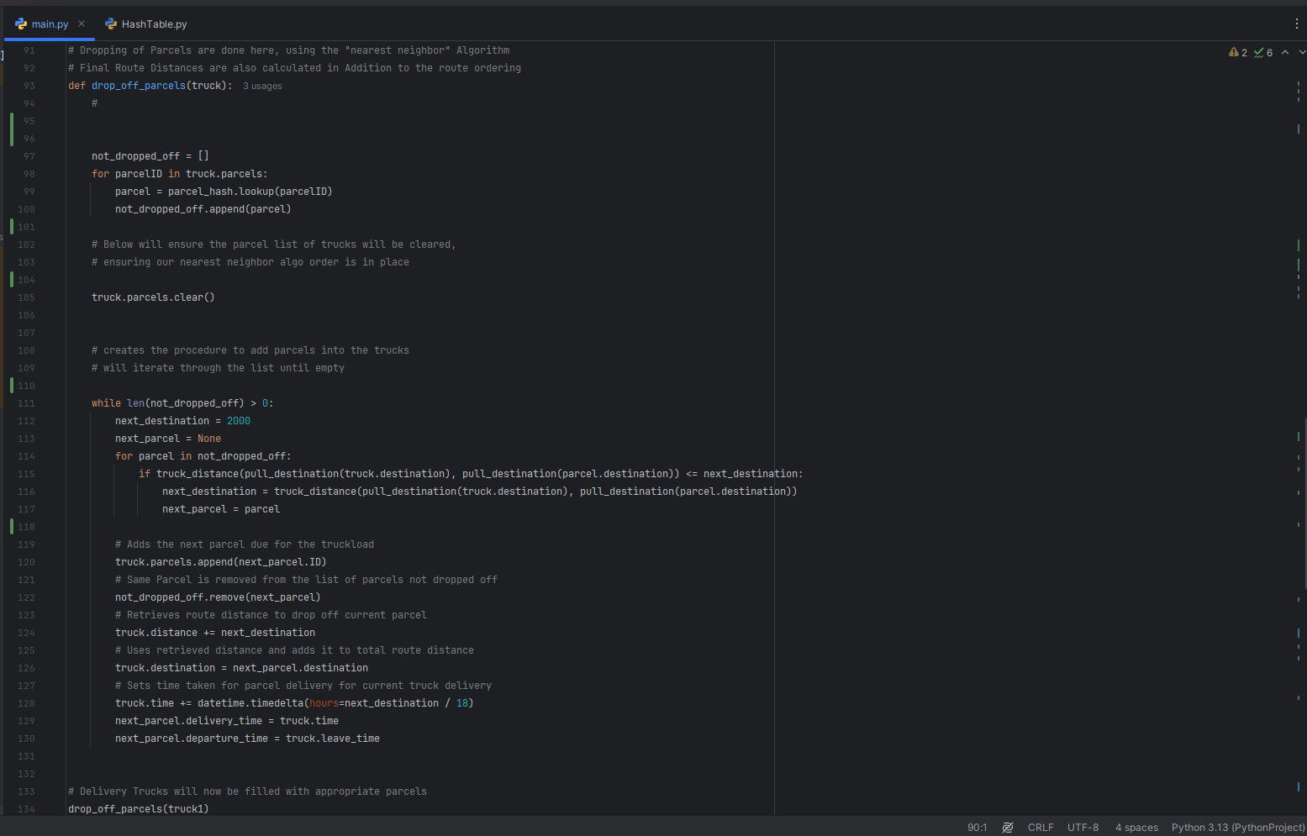
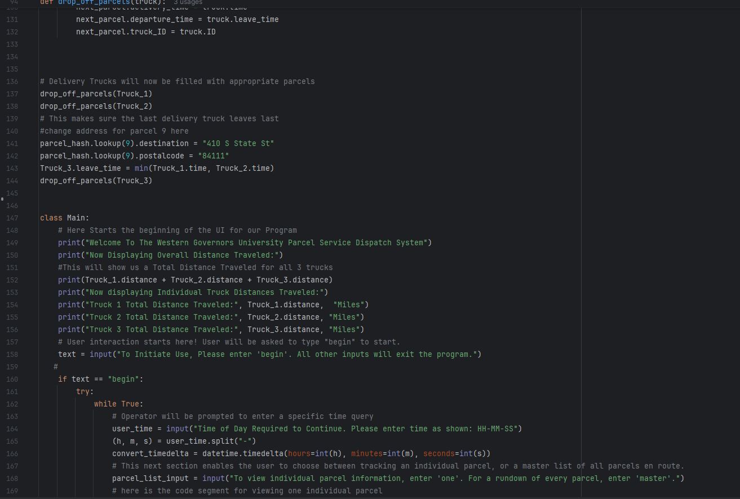

D. Interface
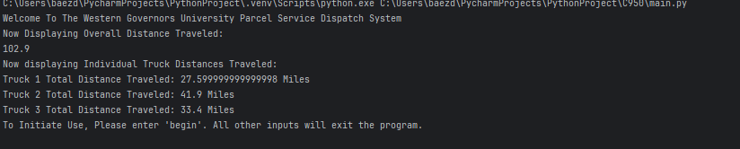

D1. First Status Check
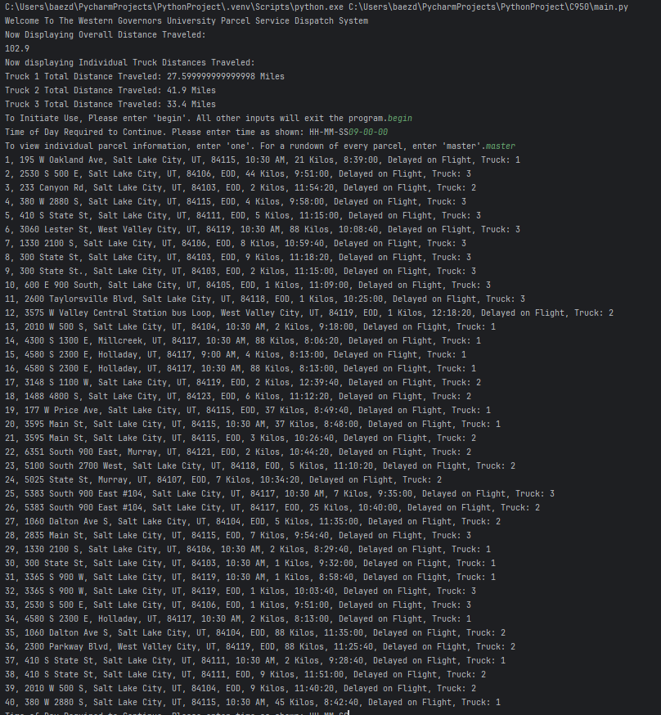

D2. Second Status Check
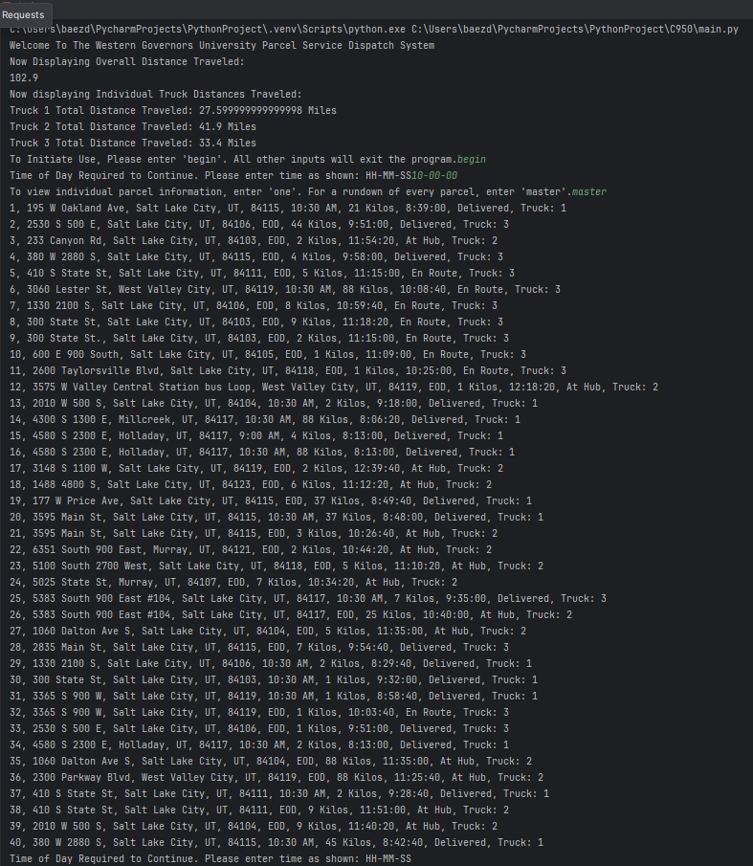

D3. Third Status Check
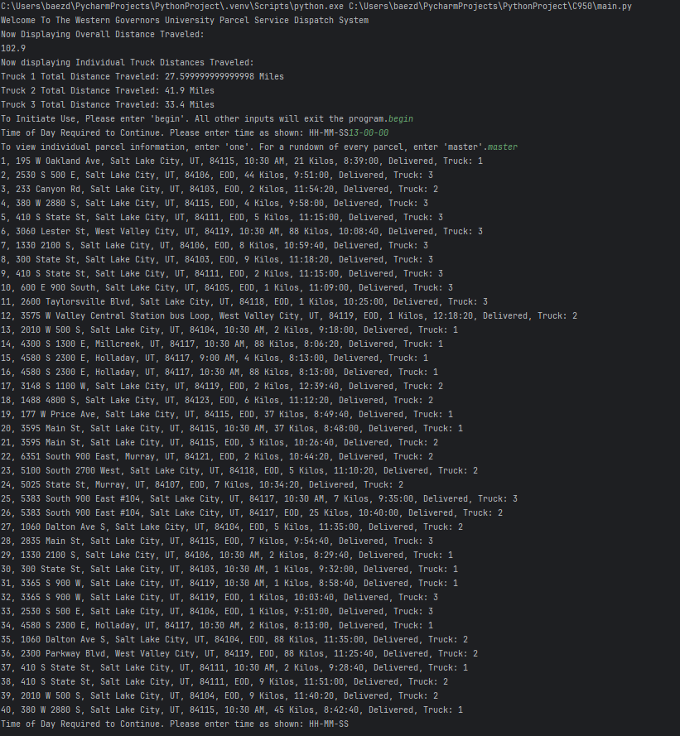

E. Screenshot of Code Execution
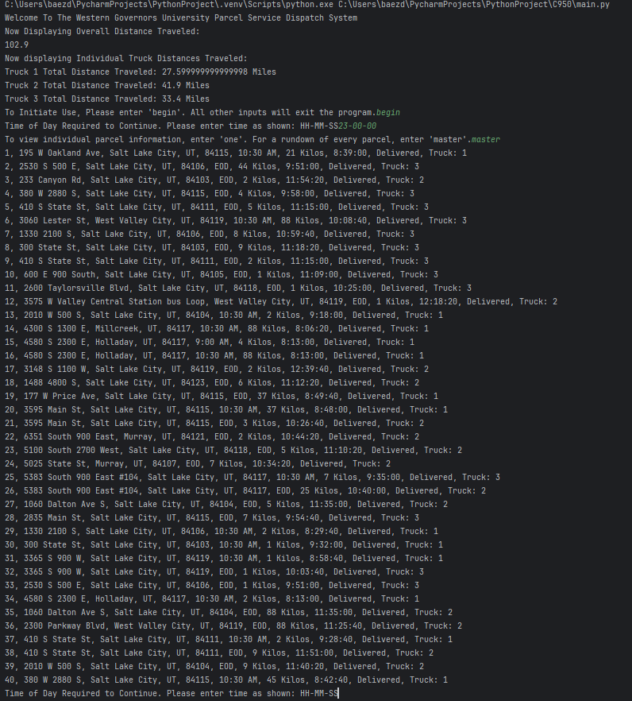

F1. Strengths of the Chosen Algorithm

The K nearest neighbor algorithm (KNN) used in the program had been chosen due to the relatively small dataset the program is working with. With a package count of merely 40 parcels, this gave the ability to choose a simple yet stable algorithm for sorting distances. As my Task 1 paper mentioned, “The choice of k is crucial, as an inappropriate value can lead to overfitting or underfitting. While it is a robust option for smaller datasets and can handle multiple features efficiently, it can suffer in performance due to the curse of dimensionality in larger and more complex datasets” (Halder, 2020). Another reason for picking the KNN algorithm was for its time and space complexity. KNN algorithms are known to have a time complexity of O(N), which is stable enough due to its categorization as a polynomial time algorithm.

F2. Verification of Algorithm
Every project will come with specific requirements. Furthermore, for this program, a requirement was that our chosen algorithm must work in a polynomial time or better. According to Wolfram Math World, “An algorithm is said to be solvable in polynomial time if the number of steps required to complete the algorithm for a given input is O(n^k) for some nonnegative integer k, where n is the complexity of the input” (Terr, 2025). A time complexity of O(N^K) is a longer computational time than that of something in O(N) time, making it a prime choice for the program. Another great accomplishment of this KNN algorithm is that it helps obtain the mileage constraints. Our Program is allowed a maximum distance traveled of 140 miles. This algorithm has been constructed to leave nearly 40 miles to spare, totaling 101.5 miles traveled overall.

F3. Other Possible Algorithms
Although the KNN Algorithm did well, it was not our only choice. Several options could have been suitable for the program. One Algorithm worth mentioning is Dijkstra's shortest path Algorithm. This algorithm works by precisely determining what the program needs to function well, finding the shortest traveling distance between two points on a graph, and constantly comparing all available options for the best results. Another algorithm we could have used to complete the route organizing is the Bellman-Ford shortest path algorithm. A nice addition to this algorithm that the Dijkstra Algorithm does not have is support for opposing edges when looking for paths.

F3a. Algorithm Differences
Although its O(N^2) Time Complexity Rivals, that of Dijkstra’s also comes in at O(N^2). The KNN algorithm was ultimately chosen for a personal interest in its methodologies. . The Dijkstra Algorithm is great for calculating shortest paths because it pre-calculates the shortest distances between all available nodes. It determines “the shortest path from a start vertex to each vertex in a graph. For each vertex, Dijkstra's algorithm determines the vertex's distance and predecessor pointer” (Lysecky, 2018). The KNN algorithm works by starting from a determined point (the parcel facility in this case) and then picking the next destination that is closest to them within a certain radius.
Bellman-Ford Algorithms can potentially save time because a special feature then supports it. “The Bellman-Ford algorithm supports graphs with negative edge weights. However, if a negative edge weight cycle exists, the shortest path does not exist” (Lysecky, 2018). I felt like although this information was nice to have, it wasn’t necessarily needed. As far as the information provided to us for creating the program goes, this feature doesn’t make or break the functionality of the program.

G. Different Approach
If I could complete this project again, I would like to complete it with a few changes. The first thing I would prefer to do is change the programming language to C++. C++ is far faster for compiling and executing code, even if both versions have the same time and space complexities. The next thing I would like to do is to allow third-party library support for the sake of ease of programming. The last thing I would like to do is make a better user interface for an easier-to-use experience for data navigation.

H. Verification of Data Structure
We implemented a Hash Table without any third parties or classes as needed. This hash table was used to receive package IDs for input and different data components. The Hash Table also served as a lookup function for the KNN algorithm to gather information on the different addresses where deliveries were needed. Furthermore, the algorithm and the hash table were successful all the way to the UI developed to access said information stored in the hash table as it is. The Hash table got this information in the first place due to an insertion function that required the information to be pulled from the CSV Data files.

H1. Other Data Structures
Two good data structures that could have been good for the program are Linked Lists and a graph, weighted or unweighted. Both have functions that would have served well for the delivery operation.

H1a. Data Structure Differences
An easy way to spot the difference between a linked list and a hash table is the approach to storing data. Hashing requires key/value pairs. Both of which are customizable in terms of names. Linked listed not to use key-value pairs. Instead, they use buckets that are located using a mandated zero-based indexing system for navigating between the buckets in said lists. A fun fact proving that hash tables are different from linked lists is that linked lists can be optionally integrated into hash tables to prevent collisions, making the hashing more foolproof.

Graphs, weighted or unweighted, are also different from the hash table in how they decide to organize the data. Graphs use edges and vertices to connect to data points instead of linking them via key-value pairs to access them. Although other algorithms, such as Dijkstra’s Algorithm, aspire to do the same to find the shortest path between points, graphs could also be implemented to secure an efficient path to deliver all packages in time instead of hashing.

I. Sources
Lysecky, R., & Vahid, F. (2018, June). C950: Data Structures and Algorithms II. zyBooks.
Retrieved March 22, 2021, from
https://learn.zybooks.com/zybook/WGUC950AY20182019/
Halder, R. K., Uddin, M. N., Uddin, Md. A., Aryal, S., & Khraisat, A. (2024, August 11). Enhancing K-nearest neighbor algorithm: A comprehensive review and performance analysis of modifications - journal of big data. SpringerOpen. https://journalofbigdata.springeropen.com/articles/10.1186/s40537-024-00973-y#citeas

